**New in This Version:**

**Bugs Fixed:**

* Scenario Simulator Options have been reconfigured to properly reflect command line option effects.

**Known Bugs:**

**Previous Release Notes**

***08 APR 2011:***

*Advanced Simulator Settings*

*The NUWC scenario simulator now prompts the user for advanced and default options before each run.*

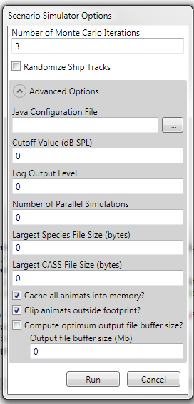

*If advanced options are not set or left as 0, they are not specified in the launching options.*

|  |
| --- |
|  |

***Bugs fixed:***

* *Batch files for nonexistent CASS runs are no longer created accidentally*
* *DBDB extracted data file format changed; CASS now receives raw OAML output as it should.*
* *CASS input files are now more properly specified and populated.*
* *Map display issue on rendering scale bars fixed*

***Known Bugs:***

* *On a clean install of ESME Workbench 2011 onto a machine that has never been used before, it is necessary to fully populate the user options dialog with valid options before attempting to load a scenario file or perform any other major action. In future releases, this will be made explicitly mandatory though a “first-run” configuration wizard.*

***25 MAR 2011:***

*3MB Integration*

*3MB is included with ESME Workbench 2011 and used for seeding, populating, and distributing animats. This release implements minimal functionality.*

*Installer updates*

*The installer now provides a direct download link to OAML data sources, as well as redistributing all necessary extraction and NUWC tools.*

|  |
| --- |
|  |

***Bugs fixed:***

* *CASS output now complies with LAND/SAND redesignations.*
* *“Save Experiment As” instabilities fixed.*
* *Bathymetric Extraction now defaults to a 0-m buffer.*
* *CASS output correctly reflects Analysis Point mode settings.*
* *CASS input files no longer include Eigenray references.*

***Known Bugs:***

* *On a clean install of ESME Workbench 2011 onto a machine that has never been used before, it is necessary to fully populate the user options dialog with valid options before attempting to load a scenario file or perform any other major action. In future releases, this will be made explicitly mandatory though a “first-run” configuration wizard.*

***21 MAR 2011:***

*NUWC Scenario Simulator Integration*

*Support for the NUWC Scenario Simulator, with a properly configured data directory structure, is now present.*

*Given a properly configured NUWC directory structure as in this example:*

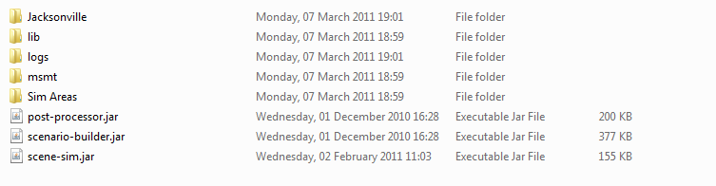

*The steps to run a full scenario are as follows:*

1. *Launch ESME Workbench and configure the NAEMO Options Dialog:*

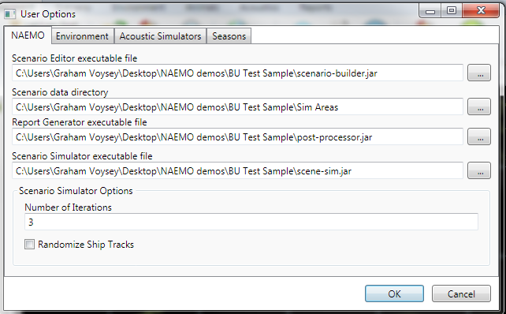

* 1. *The Scenario Editor file should point to scenario-builder.jar*
  2. *The Data Directory is the Sim Areas directory*
  3. *The Report Generator and Scenario Simulator executables are set as well.*

1. *Open a preexisting .nemo file, or create one using the scenario builder, and locate it in Jacksonville/*.nemo. At the time of this writing, Animat positions are set within the NUWC Scenario Builder.*
2. *Open this .nemo file in ESME Workbench 2011.*
3. *Extract relevant environmental data inside ESME Workbench in the usual manner.*
4. *Populate Analysis Points as desired.*
5. *Click the Export button in the Sound subgroup to export CASS run files.*
6. *(complete a CASS run that populates the correct subdirectories with computed transmission losses)*
7. *Click Simulate in ESME Workbench. A dialog will launch allowing the number of iterations and randomization state to be changed from their default values for the given simulation.*
8. *Click OK.*
9. *The Scenario Simulator will launch in the system tray and queue the correct number of simulations*
10. *When complete, launch the Report Generator from the ESME Workbench.*

|  |
| --- |
|  |

***Bugs fixed:***

* *Multiple scenarios cannot be simultaneously loaded.*

***Known Bugs:***

* *On a clean install of ESME Workbench 2011 onto a machine that has never been used before, it is necessary to fully populate the user options dialog with valid options before attempting to load a scenario file or perform any other major action. In future releases, this will be made explicitly mandatory though a “first-run” configuration wizard.*

***08 MAR 2011:***

*Acoustic Builder Support*

***Analysis Points:***  *Analysis point placement is now governed by a new UI, the Analysis Point Settings dialog. In the context of ESME Workbench, an Analysis Point is a collection of user-selectable unique sound sources at a given location.*

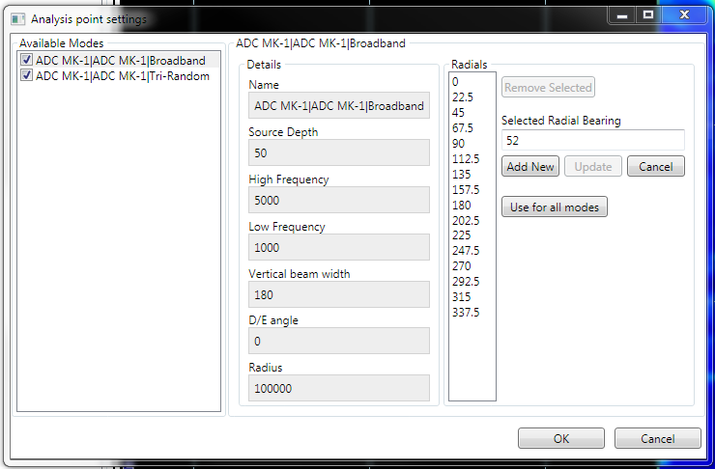

*Each unique Mode has individually customized settings. Radial directions and number can be modified per-mode, and if a particular configuration should be used for all modes, it can easily be applied uniformly.*

*Once the Analysis Point is placed by clicking OK on the Analysis Point Settings dialog, a map icon appears with vectors for each radial:*

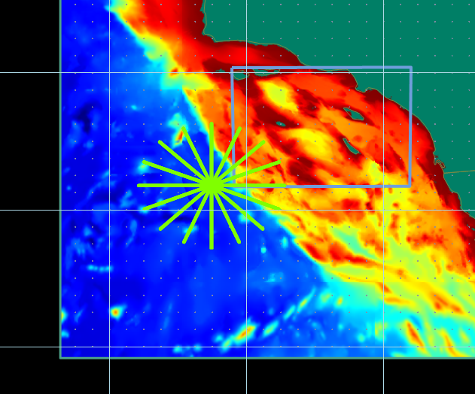

*A new layer appears in the layer list on the map display for each unique Analysis Point. Right clicking on the color indicator in the layer allows the line width and color to be changed, and right clicking on the analysis point name allows the already-placed analysis point to be edited. Changes – for example, deleting a number of radials – are updated in real time on the map. Here, 1/3 of the radials have been removed:*

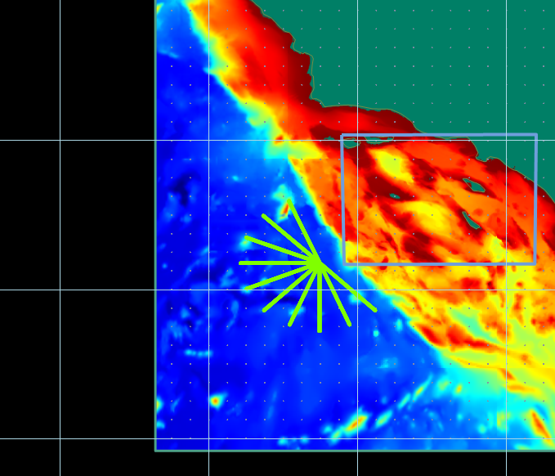

*CASSomatic output:*

|  |
| --- |
| *CASSomatic friendly acoustic outputs (INF files) are generated when the Export button on the main ribbon control is pressed. They are placed in the expected locations, along with extracted Environmental .dat files.* |

***Bugs fixed:***

* *Recent Experiments now cleaned up.*
* *A new release of the Ribbon Control, which should greatly reduce or eliminate a transient error where parts of the UI appeared black until the mouse was swept over them.*

***Known Bugs:***

* *It is possible to load two .nemo files simultaneously. This will cause a great deal of environmental database confusion, and will be disabled in a future release.*

***08 FEB 2011:***

*NUWC Environment Builder Support*

*Environmental data for a given Simulation Area is now extractable directly from available OAML databases:*

* *Bottom Sediment Type Database (BST)*
* *Digital Bathymetric Database – Variable Resolution (DBDB)*
* *Generalized Digital Environmental Model – Variable Resolution (GDEM-V)*
* *Surface Marine Gridded Climatology Database (SMGC)*

*Where available, the database-native extraction tools are used by ESME Workbench.*

*Several additional configuration options are now available in the ESME Main Options dialog for configuration of OAML Database and Extraction Tool locations.*

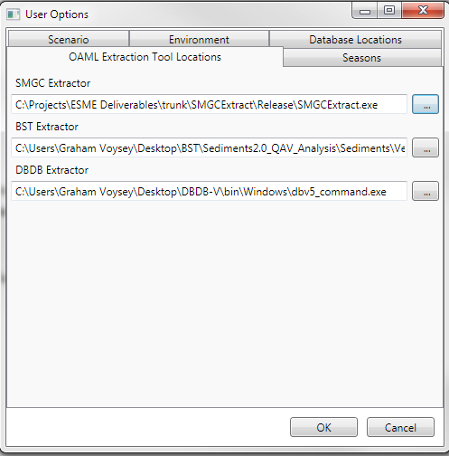

*When OAML sources are to be used, the Environment Settings button on the main ribbon control allows the user to select appropriate database resolutions and time periods for extraction:*

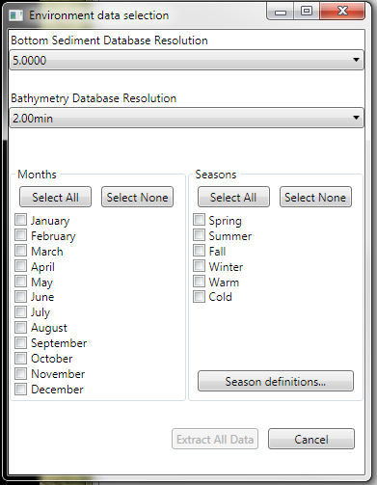

*Extracted data is stored for off-line validation and verification in the Experiment Data directory in native format (BST, DBDB: CHRTR Binary; SMGC: ASCII; GDEM-V: XML)*

*On successful extraction, map layers corresponding to each data type extracted are loaded into the main display, and can be reordered, recolored, and otherwise manipulated like any other map layer.*

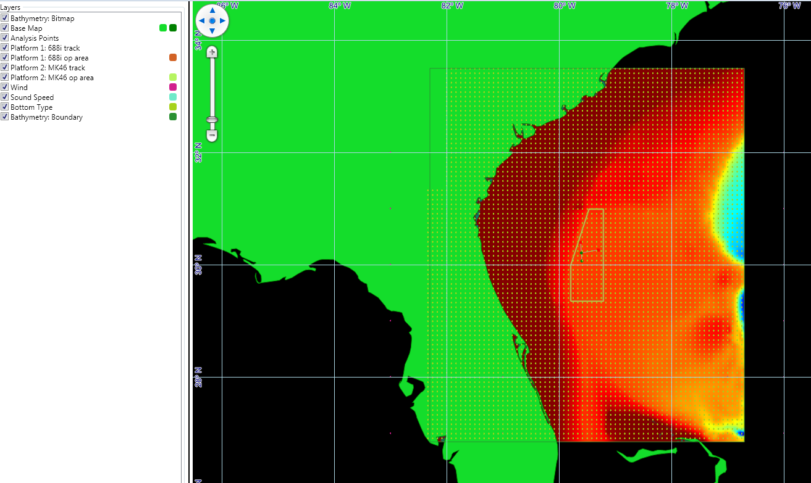

*CASSomatic output:*

*Currently, CASSomatic-friendly versions of the environment data (of the form ‘env_timeperiod.dat’) are generated and placed in the appropriate subdirectory of the directory specified as the Scenario Data Directory in the main options dialog. This will become fully user-configurable by the next release.*

***Additional Features:***

* *Bathymetric bitmap map layer support.*
* *Recent Experiments are now listed in the main ribbon dropdown menu*
* *Save As: the user can now save a current experiment with a new filename with preservation of all data.*

|  |
| --- |
|  |
|  |

***Bugs fixed:***

* *Fixed inversion of CSV Transmission Loss output*
* *Fixed transmission loss color-bar display*

***Known Bugs:***

* *Reordering the Analysis Point layer will cause ESME to crash.*

***29 NOV 2010:***

*Full Simulation Support*

*When a simulation area has been defined and specified to have an operational area containing sound sources, environmental data, animal populations, and acoustic analysis points, the exposure of each static animal to all relevant PSM can be computed and output to CSV.*

*Animat Location Files:*

*Animat Location Files (*.sce) now populate animats only in the geographical area specified by the ESME Scenario File (*.nemo), and are bounded by a Bathymetry Boundary layer.*

|  |
| --- |
|  |
| *Animats distributed within a Bathymetry Boundary* |

*Transmission Loss View:*

*Analysis Points now have a more informative transmission loss viewer, in which the acoustic parameters of all modes are visible for each transmission loss field. Additionally, the bottom profile and bathymetric data are overlaid on each transmission loss field.*

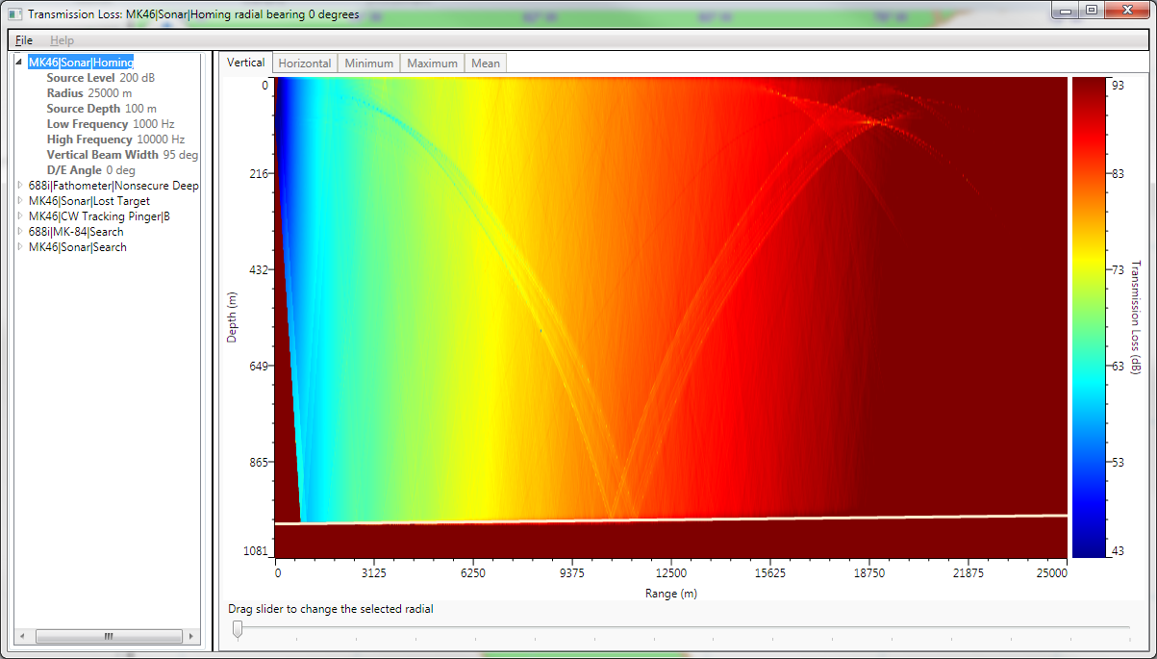

*User Interface*

*Numerous small changes in icons and menu layout for a more consistent look and feel were made. User convenience features, such as a “Zoom to Scenario” capability, and a list of Recent Experiments, were added. The list of map layers now include two colorized icons that represent the current color of each layer and allow it to be changed through context menus.*

|  |
| --- |
|  |
| *Context menus allow the Line and Area colors to be changed. For Animat layers, the Symbol size, shape, and color can be modified.* |

*Acoustic Simulators*

*In addition to Bellhop, users can select RAM for use as an Acoustic Simulator. All Simulators have default options that can be changed through the Acoustic Model Parameters Options dialog.*

|  |
| --- |
|  |
| *The Options dialog for the Acoustic Simulators is located on the Acoustics Tab.* |

*User Documentation*

*A User Guide, more thorough than these Release Notes and including step-by-step instructions for common operations, is now included with every release and is accessible in the Start Menu program group after ESME Workbench 2010 has been installed.*

***Bugs fixed:***

* *Plentiful stability and error-checking fixes.*
* *Fixed intermittent display refresh errors with transmission loss fields.*

***Known Bugs:***

* *Reordering the Analysis Point layer will cause ESME to crash.*

***29 OCT 2010:***

*Full Simulation Support*

*When a simulation area has been defined and specified to have an operational area containing sound sources, environmental data, animal populations, and acoustic analysis points, the exposure of each static animal to all relevant PSM can be computed and output to CSV.*

*Animat Location Files:*

*Animat Location Files (*.sce) contain animat populations seeded according to Business Rule specifications for probabilistic distribution of individuals. These files are generated by MMMBS, and can be loaded into ESME Workbench on the Animals ribbon tab. Once loaded, each species’ population is loaded onto the display as a separate layer:*

|  |
| --- |
|  |
| *An ESME file named test.esme that contains the Scenario File JAX Small.nemo and animats from three atlantic species.* |

*Quick Look Capability:*

*Quick Look is now more full featured and calculates transmission losses for all platforms, sources, and modes (PSM) that are operationally relevant and present. Calculations are displayed in a tree view for each unique PSM:*

|  |
| --- |
|  |
| *The Progress Bar display for current quick look calculations* |

*User Interface*

*Numerous small changes in icons and menu layout for a more consistent look and feel were made.*

***Bugs fixed:***

*- Multiple stability and error-checking fixes.*

***Known Bugs:***

*- Transmission Loss Fields are currently not viewable by the user after a Quick Look or Analysis Point has finished computing.*

*- Map artifacts on zoom persist occasionally.*

***08 OCT 2010:***

*Scenario File Support:*

*Scenario files (*.nemo) are now loadable. Further, they are required to be present before running a Quick Look is possible. In contrast to Iteration 2, presence of bathymetric and other data is implicitly known through the scenario file, rather than having to be explicitly specified by the user.*

*Experiment Files:*

*Experiment files (*.esme) can now be saved and opened, so that experiments can be resumed at a later date. File associations are performed at installation such that double-clicking on a previously saved .esme file will open ESME Workbench and load that experiment.*

|  |
| --- |
|  |
| *An ESME file named test.esme that contains the Scenario File JAX Small.nemo.* |

*Quick Look Capability:*

*Quick Look now has a more full-featured Transmission Loss Field viewer. Vertical fields can be viewed for all radials with a dynamically adjustable color bar, and the field data can be exported to one of three image formats (PNG, JPEG, BMP) or comma-separated value files (CSV).*

*Quick Look invocation is as follows:*

* *Load a scenario file*
* *Select the Environment ribbon control, and click on Settings to verify that the extracted data is correct. Press OK.*
* *Select the Experiment ribbon control, and run a Quick Look by clicking the Quick Look button, and then clicking anywhere within the simulation area.*
* *A dialog will display the progress of the radial calculator, and will close and launch the transmission loss field viewer when complete.*

|  |  |
| --- | --- |
|  |  |
| *The Progress Bar display for current quick look calculations* | *The Transmission Loss Viewer displaying a vertical field.* |

***Bugs fixed:***

*- Multiple stability and error-checking fixes.*

*- Quick Looks cannot be run in areas for which there is no bathymetric data (eg, outside the sim area).*

***Known Bugs:***

*- The layer side panel incorrectly reports the checkbox status of individual layers.*

*- The recent experiments view in Workbench Options is not populated with recent experiments.*

*- Very many (25+) layers open for prolonged periods may cause text to display on the map control; “The projection is not open…”, which is a known issue with the Map Control.*

***20 SEP 2010:***

*User Configuration Options:*

*Default directories and paths to the Environment Builder and associated files can now be set in the File tab on the ESME Workbench Ribbon Control.*

*Environment File Parsing:*

*Environment (*.eeb) files can now be read, and are required to be loaded before a Quick Look can be performed.*

*Quick Look Capability (rudimentary):*

*Once an Environment File has been loaded, the Quick Look button on the Experiment Tab can be used to perform a quick look within a Simulation Area for which bathymetry data is known.*

*When the Quick Look button is pressed, the mouse cursor changes to a crosshair to indicate that ESME Workbench is now in Quick Look Mode. Left-clicking within a loaded Simulation Area will cause a transmission loss field to be calculated for latitude and longitude at the point which is clicked, and a contextual pop-up detailing the parameters that are being used will display. During the time when the transmission loss field calculator (Bellhop) is running, the cursor changes to a spinning wait icon.*

*The resulting transmission loss fields are displayed as heat maps in a pop-up after the simulation is complete.*

*Quick Look mode can be exited by pressing the Esc key.*

*Scenario Builder and Environment Builder:*

*The Builders can be launched once its location is specified via the User Configuration Options.*

*Ribbon Control*

*The Ribbon Control is now more populated with representative option icons for features required in upcoming iterations.*

*Installer*

*A more detailed installation package is now included, including a step-by-step installation wizard and uninstaller.*

*Layer Selectivity and Reordering:*

*Shape layers are now displayed in a tree-view on the left hand side of the main map display. Their display order can be changed with the arrow buttons at the bottom of the tree display, and their visibility states can be toggled via a checkbox.*

***Bugs fixed:***

*- The Latitude and Longitudes of the cursor are now displayed on the bottom of the map.*

*- Complex shape files (eg, a shape file containing coastal outlines of all of Hawaii) now load faster.*

***Known Bugs:***

*- The installer prompts for an installation directory, which defaults to c:\ Depending on UI interaction choices of non-default path, it may or may not display some formatting error messages. Regardless of the directory selected in this point in the wizard, ESME Workbench 2010 is installed into C:\Program Files\ESME Workbench\.*

*- The installer's "click here to view README.TXT" button is currently inoperable.*

*- If a NEMO file fails to load because it contains inconsistent data, the resulting ESME Workbench error file is unclear.*

*- ESME Workbench will crash if the user attempts to edit or modify Scenario and Environment files if the User Configuration Options are improperly set.*